# OZcoin Affiliate System

The OZcoin Affiliate sales system is proposed as a complimentary approach to other marketing and sales processes.

The objective is to have multiple Affiliate Companies. These are organizations that have purchase an annual license from Data Discovery to act as Affiliate Principals. They will receive commission from every OZcoin sale. All commissions are payable by the seller of the coin and it is automatically paid from the OZcoin smart contract.

Any person that wants to become an affiliate needs to open their OZcoin Wallet via an affiliate link. AN affiliate link is a hyper-link that navigates the user to a web page where they can open an OZcoin wallet. The affiliate link automatically sets the Affiliate Company Account and the Affiliate Account in the new wallet. The linked Affiliate Company account will always be that of the Affiliate Principal (company) from which the original wallets were created. The Affiliate Account is the account from which the link was sent.

They will also need to purchase a set value e.g. US$1,000 worth of OZcoin and deposit an additional US$50 worth of Ether into their wallets. (Data Ether Exchange)

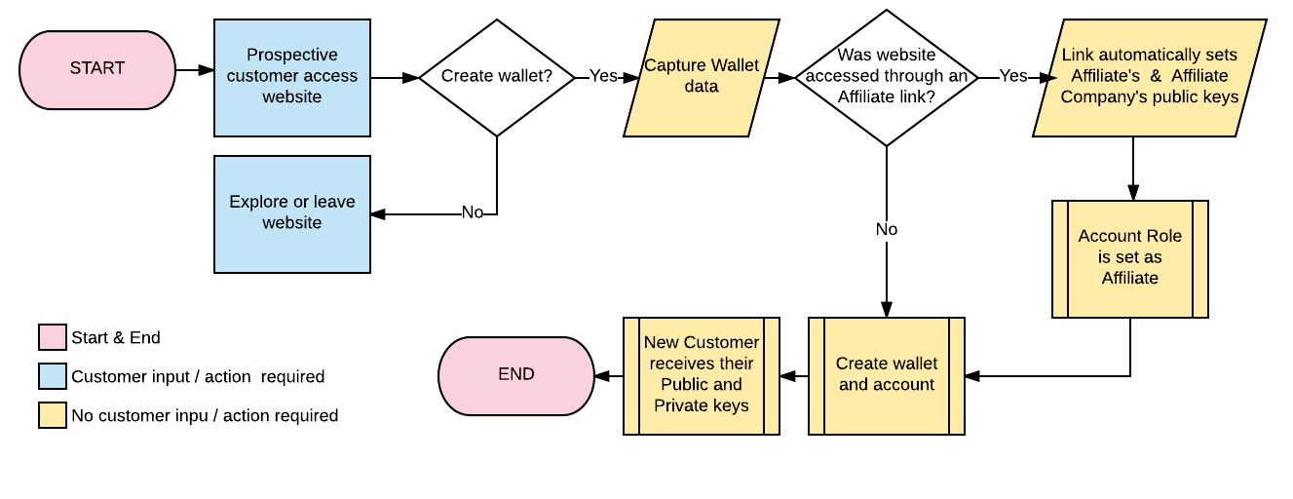

Every time that new customer buys OZcoin through their affiliate wallet, the affiliate registered against the seller’s account will receive a set % commission for that transaction. The commission will be payable by the seller. This commission is a percentage as set and agreed to by OZcoin & Citi Gold (Profit From The Net) and managed by the OZcoin Administrator.

All affiliate commissions will be payable in Ether. Because OZcoins can only be purchased in Ether, the smart contract will automatically take the Affiliate commission and Affiliate Company commissions, where relevant.

The set OZcoin transaction fee, payable in uOZC applies to all transfers, including Affiliate sales.

Affiliates will be earning commission from every transaction their customers execute for as long as they partake in trading OZcoins.

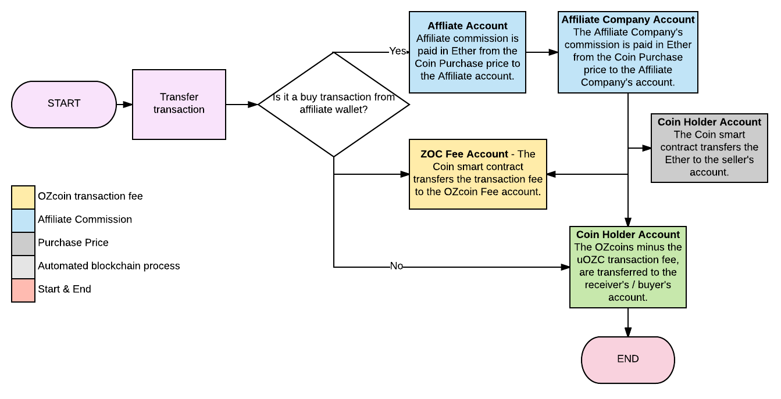

# The Affiliate Process

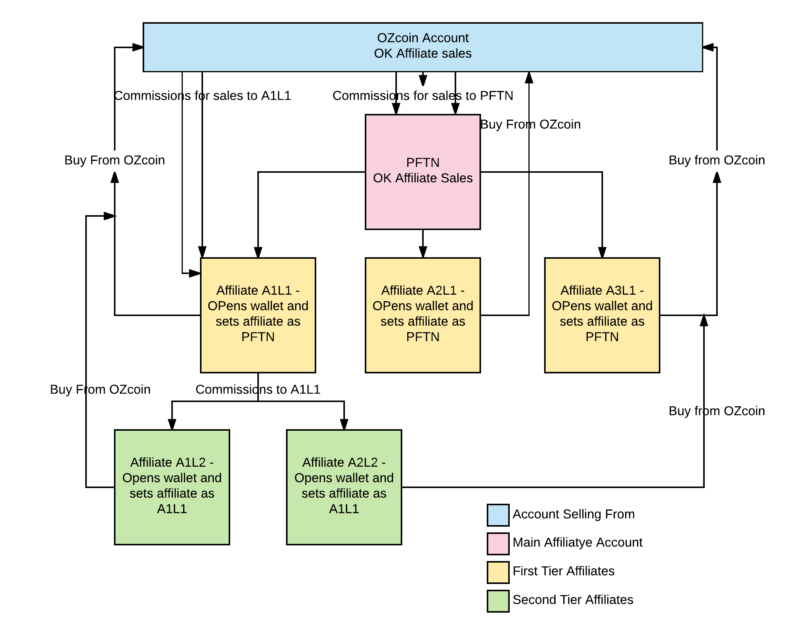

To establish an Affiliate Company with affiliates, the following process applies.

1. A company or person opens an OZcoin Wallet
2. They email the Administrator and request to be appointed as an Affiliate Company / Principal.
3. The Administrator changes their account role from Coin Holder to Affiliate Principal
4. The new Affiliate Principal receives a link through which new prospective affiliates can open an OZcoin Wallet.
5. Any OZcoin Wallet that is opened via such a link, automatically links the original Affiliate Company’s account and the Affiliate from which they received the link’s account to the wallet.
6. Wallet generated buys and sells can only take place through affiliate wallets. So every time an OZcoin is sold and bought through an OZcoin wallet, the affiliate and affiliate company linked to that wallet, receives the specified commission.
7. Any affiliate can send their affiliate link to any other person. The moment that person opens an OZcoin wallet through this link, the process repeats.

Affiliate1 sets in their wallet PFTN as their affiliate. As it is the Affiliate Company, PFTN will also be set as the purchaser’s Affiliate Company. Affiliate1 has to purchase 100OZcoins from the OZcoin Account. PFTN gets that commission as it is set as Affiliate1’s account affiliate. PFTN also receives the Affiliate Company commission.

When Affiliate1 gets another customer or recruits another affiliate, the new recruits or customers enter Affiliate1’s public key as their registered account affiliate. They will not be able to enter their own account number here. When the new affiliates or customers purchase any OZcoins from any account that has Okayed affiliate sales, Affiliate1 receives the commission and PFTN receives the st Affiliate Company commission.